SLEEP – SCREEN TIME & SLEEP DEBT ANALYTICS
Dashboard Analysis Report
Power BI Dashboard | Analytical Summary and Business Insights

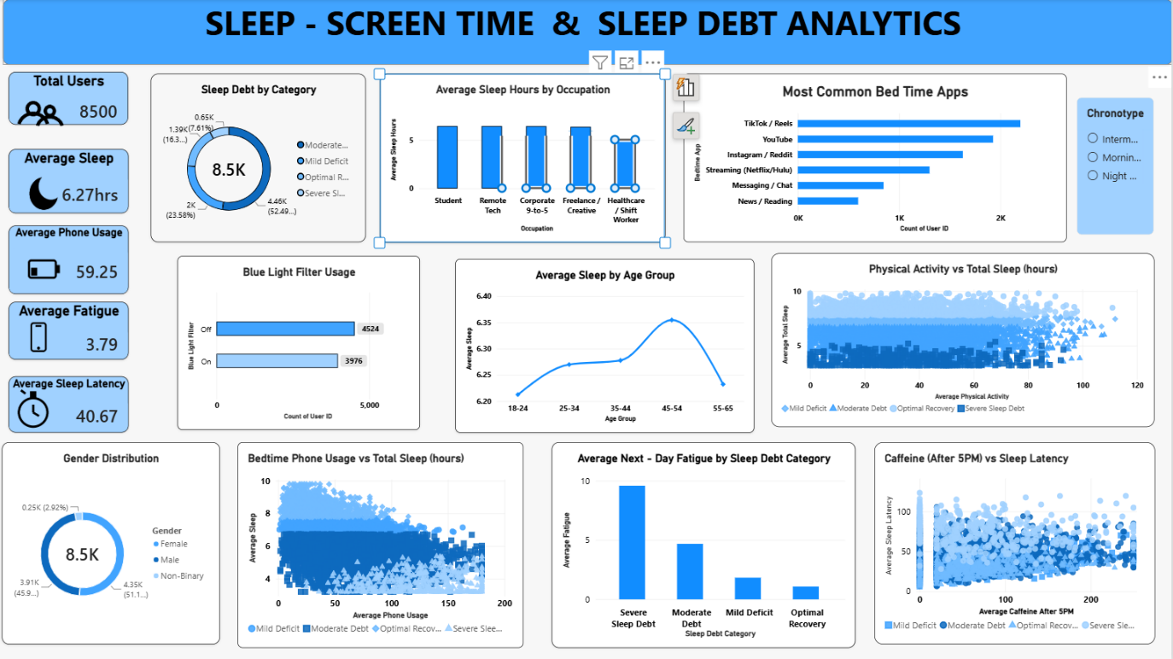
Prepared based on the dashboard visual provided

1.Executive Summary
This report presents an analytical review of the “Sleep – Screen Time & Sleep Debt Analytics” dashboard. The dashboard combines key performance indicators, categorical comparisons, trend analysis, and relationship charts to understand how sleep duration, sleep debt, phone usage, bedtime applications, physical activity, caffeine consumption, and demographic factors are related.
The dashboard represents approximately 8.5K users. The overall average sleep duration is 6.27 hours, while average phone usage is 59.25 units as displayed in the dashboard. Average fatigue is 3.79 and average sleep latency is 40.67. The visualizations indicate that sleep quality is not determined by a single factor; instead, several lifestyle and behavioral variables interact with sleep outcomes.
Overall findings:
- The average sleep duration of 6.27 hours suggests that the population is, on average, below a commonly recommended 7–9 hour sleep range for many adults.
- Sleep-debt categories are concentrated around moderate and mild deficit levels, while optimal recovery represents a smaller share.
- Student, remote-tech, corporate, freelance/creative, and healthcare/shift-work occupations show differences in average sleep duration.
- TikTok/Reels and YouTube are the most common bedtime app categories shown in the dashboard.
- Users with higher fatigue are concentrated in the severe sleep-debt category, showing a strong practical relationship between inadequate recovery and next-day fatigue.
- Phone usage and bedtime phone usage show a negative relationship with sleep duration in the dashboard, although the scatterplots also contain substantial variation.
2. Dashboard Objectives
The dashboard is designed to answer practical analytical questions about sleep behavior and digital lifestyle patterns. Its primary objectives are:
- Measure the overall sleep and recovery status of the user population.
- Identify the distribution of users across sleep-debt categories.
- Compare sleep duration across occupations and age groups.
- Understand bedtime application usage patterns.
- Examine the association between phone usage and sleep duration.
- Study physical activity in relation to total sleep.
- Evaluate the relationship between caffeine consumption after 5 PM and sleep latency.
- Compare next-day fatigue across sleep-debt categories.
- Provide actionable insights for improving sleep behavior and recovery.

3. KPI Summary
KPI | Dashboard Value | Interpretation
Total Users | 8,500 | Large user sample represented in the dashboard.
Average Sleep | 6.27 hrs | Indicates relatively short average sleep duration.
Average Phone Usage | 59.25 mins | Shows substantial digital-device usage.
Average Fatigue | 3.79 | Represents the average fatigue level shown by the dashboard.
Average Sleep Latency | 40.67 | Indicates the average time/latency measure before sleep.

4. Detailed Dashboard Analysis
4.1 Sleep Debt by Category
The donut chart shows that the largest group is the Moderate Deficit category at approximately 4.46K users (52.49%). Mild Deficit accounts for about 2.00K users (23.58%), while Optimal Recovery is around 1.39K users (16.3%). Severe Sleep Debt is the smallest group at approximately 0.65K users (7.61%). The distribution indicates that sleep deficiency is widespread, with the majority of users falling into deficit categories.
Moderate sleep deficit is the dominant category and should be a primary target for improvement programs.
Optimal recovery represents a comparatively smaller proportion of the population.
Severe sleep debt, although smaller in volume, is important because it is associated with higher fatigue.
4.2 Average Sleep Hours by Occupation
The occupation comparison shows differences in average sleep duration across job groups. The chart places Student, Remote Tech, Corporate 9-to-5, Freelance/Creative, and Healthcare/Shift Worker categories side by side. The visible values are generally clustered around the six-hour range, with healthcare/shift work appearing comparatively lower.
Work schedule and occupational demands may influence sleep duration.
Shift workers may require additional interventions because irregular schedules can make consistent sleep difficult.
Occupational comparisons can support targeted wellness recommendations.
4.3 Most Common Bedtime Apps
TikTok/Reels has the highest count, followed by YouTube. Instagram/Reddit and streaming services are also common, while messaging/chat and news/reading show lower counts. The pattern suggests that short-form video and entertainment platforms are prominent sources of bedtime screen exposure.
Short-form video platforms should be considered a major bedtime screen-time driver.
Reducing stimulating or prolonged content consumption before sleep may support better sleep routines.
App-level analysis can help users identify specific habits rather than treating all screen time equally.
4.4 Blue Light Filter Usage
The dashboard shows 4,524 users with the blue-light filter Off and 3,976 with it On. Usage is therefore relatively balanced, but slightly more users do not use a blue-light filter.
Blue-light-filter adoption is an opportunity for a simple behavioral intervention.
However, the dashboard should not be interpreted as proving that blue-light filters alone improve sleep.
4.5 Average Sleep by Age Group
Average sleep varies by age group. The chart shows the highest average around the 45–54 group at approximately 6.35 hours, while the 18–24 and 55–65 groups are lower. The overall range is relatively narrow, indicating that age is associated with some variation but does not fully explain sleep duration.
The 18–24 group may benefit from education around sleep schedules and bedtime device use.
The 55–65 group may require attention to consistent routines and other lifestyle factors.
Age should be analyzed together with occupation, activity, and digital behavior.
4.6 Physical Activity vs Total Sleep
The scatter plot compares physical activity with average total sleep and separates observations by sleep-debt category. The points are widely distributed, suggesting that physical activity has a relationship with sleep but is not the only determinant. Different sleep-debt groups occupy different regions of the chart.
Regular physical activity can be considered as part of a broader sleep-health strategy.
The large amount of scatter indicates that additional variables should be considered before making causal conclusions.
4.7 Gender Distribution
The dashboard contains approximately 8.5K users across Female, Male, and Non-Binary categories. Male and Female users form the largest groups, while the Non-Binary category is much smaller.
Demographic segmentation can help identify whether sleep patterns differ between groups.
Small subgroup sizes should be interpreted carefully to avoid overgeneralization.
4.8 Bedtime Phone Usage vs Total Sleep
The scatter plot indicates a broad inverse pattern: higher bedtime phone usage is generally associated with lower average sleep. The relationship is not perfectly linear because users with similar phone usage can still have different sleep durations.
Bedtime phone usage is a potentially important behavioral indicator for sleep reduction.
A useful intervention is to establish a device-free period before bedtime.
Correlation should not be treated as proof of causation without additional statistical testing.
4.9 Average Next-Day Fatigue by Sleep Debt Category
This is one of the clearest comparisons in the dashboard. Severe Sleep Debt has the highest average next-day fatigue, followed by Moderate Debt. Mild Deficit is considerably lower, and Optimal Recovery has the lowest fatigue.
Sleep debt is strongly associated with next-day fatigue in the displayed data.
Reducing severe and moderate sleep debt should be a priority because it may improve daytime functioning.
This chart provides a strong business and wellness justification for sleep-improvement interventions.
4.10 Caffeine After 5 PM vs Sleep Latency
The scatter plot compares caffeine consumption after 5 PM with average sleep latency. The points show substantial variation, with no simple one-to-one relationship visible from the dashboard alone. This suggests that caffeine may be one contributing factor among several factors influencing how quickly users fall asleep.
Late-evening caffeine consumption should be monitored as part of sleep-hygiene analysis.
Further statistical testing would be useful to quantify the strength of the relationship.
5. Key Cross-Dashboard Insights
Sleep deficiency is widespread: more than half of users are shown in the Moderate Deficit category.
The population averages only 6.27 hours of sleep, which provides a clear reason to focus on sleep improvement.
Bedtime entertainment is dominated by TikTok/Reels and YouTube, suggesting that digital content consumption is a key behavioral area.
Higher bedtime phone usage tends to coincide with lower sleep duration, making bedtime device use a high-value intervention area.
Severe sleep debt corresponds to the highest next-day fatigue, indicating that insufficient sleep has an important daytime impact.
Occupation and age both show variation in average sleep, but the differences are smaller than the overall behavioral patterns.
Physical activity and late-evening caffeine appear relevant, but their relationships with sleep are more complex and require deeper analysis.
6. Recommendations
Introduce a bedtime digital curfew: Encourage users to reduce phone and entertainment-app usage during the 30–60 minutes before planned sleep.
Target moderate and severe sleep debt: Create personalized alerts or wellness guidance for users repeatedly classified as moderate or severe sleep debt.
Promote consistent sleep schedules: Especially target students and shift workers, where irregular schedules may contribute to reduced sleep.
Review bedtime app behavior: Use app-level insights to encourage reduction of high-engagement short-form video and streaming activity at night.
Encourage physical activity: Promote regular daytime activity while recognizing that activity alone may not resolve sleep deficits.
Reduce late-evening caffeine: Recommend limiting caffeine after 5 PM for users who experience long sleep latency, while considering individual differences.
Use the dashboard for continuous monitoring: Track whether interventions improve sleep duration, reduce fatigue, and increase the proportion of users in optimal recovery.
7. Suggested Advanced Analysis
Calculate correlation coefficients between bedtime phone usage, total sleep, sleep latency, fatigue, and caffeine consumption.
Build a regression model to predict sleep duration or sleep debt category.
Use classification models to identify users at risk of severe sleep debt.
Create a time-based analysis if date/time-level data are available.
Add slicers for gender, age group, occupation, sleep-debt category, and chronotype for deeper segmentation.
Track KPIs before and after an intervention to measure improvement.
Validate dashboard metrics against the underlying dataset and clearly document the units for phone usage, fatigue, and sleep latency.
8. Conclusion
The Sleep – Screen Time & Sleep Debt Analytics dashboard provides a clear overview of sleep behavior across 8,500 users. The strongest message from the dashboard is that sleep deficiency and next-day fatigue are important issues within the population. Moderate sleep deficit is the largest category, average sleep is 6.27 hours, and severe sleep debt is associated with the highest fatigue.
Digital behavior is another important theme. TikTok/Reels and YouTube are the most common bedtime applications, and the bedtime phone-usage chart suggests that heavier nighttime phone use is generally associated with less sleep. The dashboard therefore supports practical interventions focused on bedtime screen reduction, consistent sleep schedules, reduced late-evening caffeine, and improved lifestyle habits.
Overall, the dashboard can be used not only as a reporting tool but also as a decision-support tool. With additional statistical analysis and user-level tracking, it can be extended into a predictive sleep-risk and wellness monitoring solution.

